**Mini Project Report**

Google cloud-based web application for Career Guidance

**By:**

**Name: Harsh Gupta**

**Section: CCIS**

**Class Roll no: 25**

**University roll number 2014670**

**Problem Statement**

**Create a Google Cloud based web application for Career Guidance**

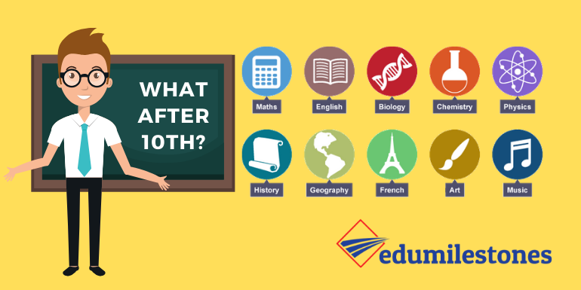

**Introduction**

**A career guidance website for student professionals whoever wants some help in guidance. I have created the website with the help of HTML and CSS. After crafting a proper website with great content with multiple webpages I have used Google cloud platform for hosting of my website which is a static website.**

**Languages used**

* **HTML:- used for creating web pages also called hypertext Markup language. It uses lot of tags and codes to create a web page we can use it for structuring a website so that it looks good with the well-arranged content.**

**Html is easy to learn and use. Skeleton of a website is prepared with html.**

* **CSS- CSS is s style sheet language that completely changes how the webpage looks with the help of codes and is used for decorating the website as well as properly arranging the website content as only Html just feels like a skeleton.**

Approach for designing the website

**Approach for designing the website**

**I have created a static website with the help of HTML and then styled it with CSS so that it looks good. I have used various images as well as created some graphics so that the website looks good.**

**Career Guidance**

**career guidance is important for someone who is unsure or wants to explore his/her career paths. Then content has been taken from experienced sites as well as well trained individuals to improve the quality of the content of the website.**

**Career guidance path**

**Class 10**

**most of us require our first guidance in class 10 between math science biology computer commerce and what not to confuse the kids.**

**After class 12**

**We want to know which would be good for us should we be an engineer doctor so some specific path.**

**Choose what you feel like is the one you would love to do even after 10 years.**

**"There are so many other professions so why not consider them along with all the things you feel like running a startup, musician, photographer, bodybuilder, swimmer, dancer, editor videographer etc... a lot more."**

**Google Cloud Platform**

**GCP is a public cloud vendor like Amazon Web Services, Alibaba, Oracle and Microsoft Azure. With GCP along with other services, customers are able to access computing resources stored in big data centers spread around the world for free or on a pay-per-use basis.**

**All cloud vendors offer a set of computing services to do everything cost management to data management to delivering web and video over the web to AI and machine learning tools. CDN tools storage tools etc.**

**Cloud has a lot of advantages when it comes to hosting webpages which I will talk in the next slide.**

**The services offered by the google cloud for hosting are VM instances and storage buckets and some more which make it easier for us to host and maintain a website.**

**Google cloud platform**

**Strengths**

* **Cost-saving**
* **widely available**
* **highly scalable**
* **New and useful tools**
* **easy to use and set up**
* **Reliable**
* **On-demand**
* **a lot more.**

**Cost Savings**

**Cost saving is one of the biggest benefits in Cloud Computing. It helps you to save substantial capital costs of hardware office and all as it does not need any physical hardware investments. Also, you do not need trained professional to maintain the hardware. The buying and managing of equipment are done by the service providers.**

**Strategic edge**

**Distributed computing offers an upper hand over your rivals. It is one of the most outstanding benefits of Cloud benefits that assists you with getting to the most recent applications any time without investing your energy and cash on establishments.**

**Collaboration**

The distributed computing stage helps representatives who are situated in various geologies to team up in a profoundly helpful and secure way.

**References**

**For building the website**

* [**https://www.w3schools.com/css/css_intro.asp**](https://www.w3schools.com/css/css_intro.asp)
* [**https://stackoverflow.com/**](https://stackoverflow.com/)
* [**https://www.tutorialspoint.com/**](https://www.tutorialspoint.com/)

**For hosting it on cloud**

* [**https://cloud.google.com/storage/docs/hosting-static-website**](https://cloud.google.com/storage/docs/hosting-static-website)
* [**https://www.guru99.com/**](https://www.guru99.com/)